MAILBOX ALERT SYSTEM

Use Case Specification: Arduino Connection

Version 1.0

Revision History

|  |  |  |  |
| --- | --- | --- | --- |
| **Date** | **Version** | **Description** | **Author** |
| 30/03/2017 | 1.0 | Arduino Inter-Connection | K.Sriram  N.Vignesh  J.Sachin Fernandez |
|  |  |  |  |
|  |  |  |  |
|  |  |  |  |

Table of Contents

1. Use Case Name 3

1.1 Brief Description 3

2. Flow of Events 3

2.1 Basic Flow 3

2.2 Alternative Flows 3

2.2.1 < First Alternative Flow > 3

2.2.2 < Second Alternative Flow > 3

3. Special Requirements 3

4. Preconditions 3

5. Post Conditions 3

6. Extension Points 3

Use Case Specification: Arduino Inter-connection

# Arduino Interconnection

## Brief Description

The purpose of this use case specification is to establish the Inter-connection between the Arduino UNO, Photo-resistor and the GSM Module. Then after the connection is established, the letter is detected by the photo resistor and the signal is transmitted to the Module, and the alert message is sent to the resident.

**2. Flow of Events**

## 2.1 Basic Flow

In this flow, the Inter-connection is established between the Arduino UNO, photo resistor and the GSM module and the letters are detected by the photo resistor which runs on the control of the Arduino.

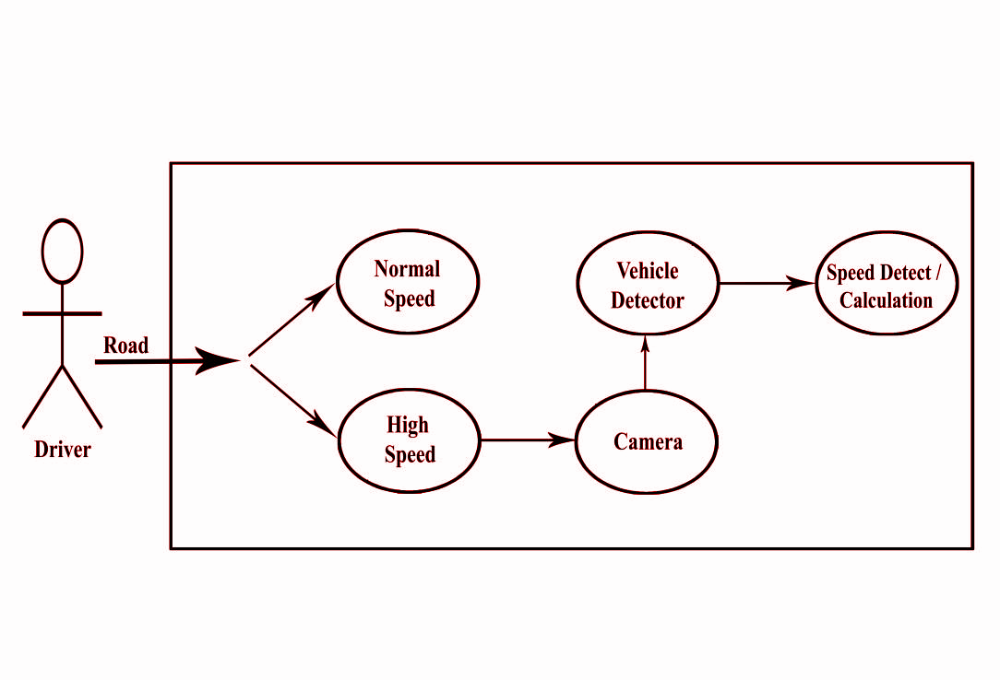

## Alternative Flows

### 2.2.1 < First Alternative Flow >

#### 2.2.1.1 < An alternative sub-flow >

### 2.2.2 < Second Alternative Flow >

# Special Requirements

PHOTORESISTOR – Photo resistors also exhibit a certain degree of latency between exposure to light and the subsequent decrease in resistance, usually around 10 milliseconds.

GSM MODULE – GSM networks operate in a number of different carrier frequency ranges (separated into GSM frequency ranges for 2G and UMTS frequency bands for 3G), with most 2G GSM networks operating in the 900 MHz or 1800 MHz bands. Where these bands were already allocated, the 850 MHz and 1900 MHz bands were used instead (for example in Canada and the United States). In rare cases the 400 and 450 MHz frequency bands are assigned in some countries because they were previously used for first-generation systems.

# Preconditions

First Priority for this project is Photo resistor which detects whether a letter is received or not.

The signal is been send by photo resistor to GSM Module and sent to the resident.

# Post Conditions

The detecting of letters in the Mailbox and transmits the alert message through the module.

# Extension Points

Going to provide details about the letter received.